Create a PO
PO: 500000666719
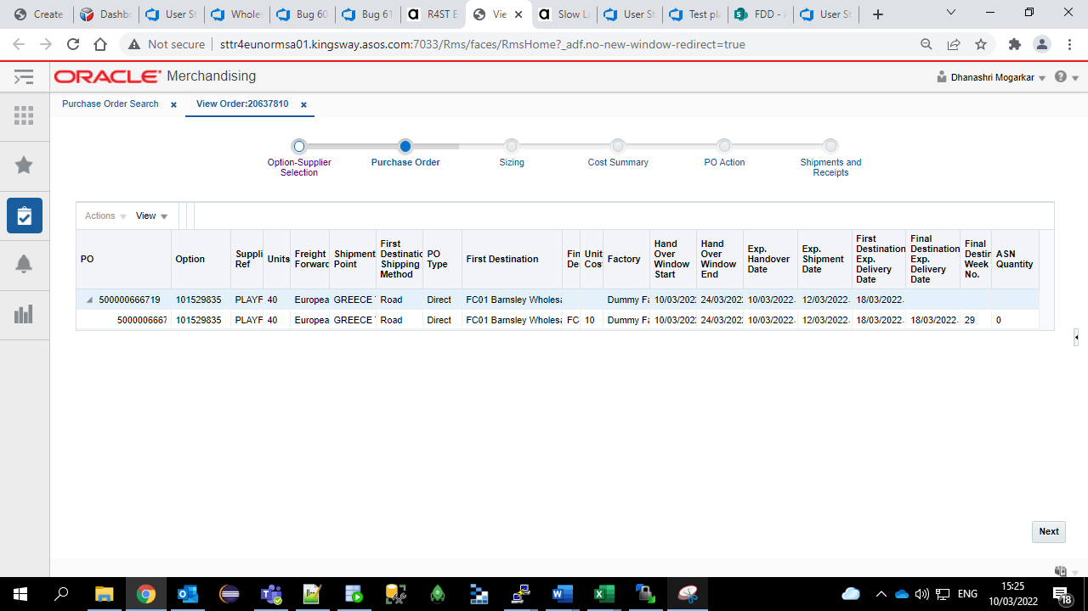
Process it SO file through Putty
You can check the details of SO file in database as below
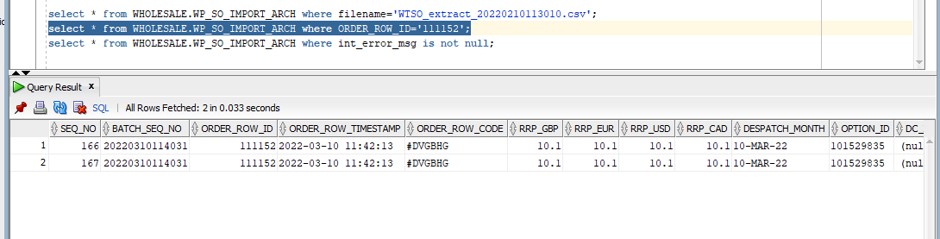
Create ASN for the same PO with the help of ASOS NET URL
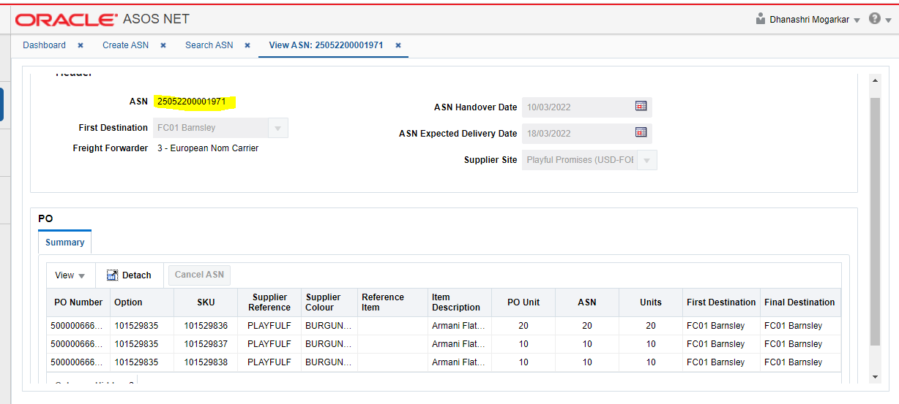

Follow the steps mentioned in the “KT doc_Transfer Discrepancies” document to Partially (Over/under) receipt the same PO through database.
Also change the receive date of the PO as per your requirement of 1-7 days/8-14 days/15+ days using a query mentioned in the document

You can check the status of receipting on below PO screen we can see more units are receipted

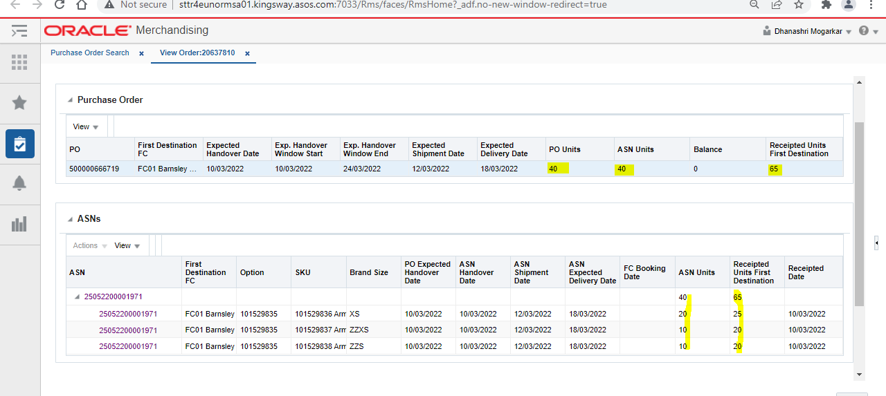
Now refresh the dashboard by running a Putty command and you will be able to see that record in post unit receipt variance dashboard as follows
